C O N T A C T
​
P R I V A T E C O N S U L T A T I O N
Wednesday, 3 p.m. to 8 p.m
or by appointment
​
A D D R E S S
10/2, Theresianumgasse / Ground Floor
1040 Vienna
​
A P P O I N T M E N T
Administrative Coordinator
Mr. Wolfgang Wiener, MSc.
Phone: +43 680 1405256
​
or
Department of Neurosurgery
Landstrasse Municipial Hospital, Vienna
Mrs. Michaela Fischer (Administrative Coordinator)
Phone. +43 71165 4508
​
or
E-mail: martin.ortler@gesundheitsverbund.at
​
​
C A N C E L L A T I O N
Please cancel at least 24h before the consultation
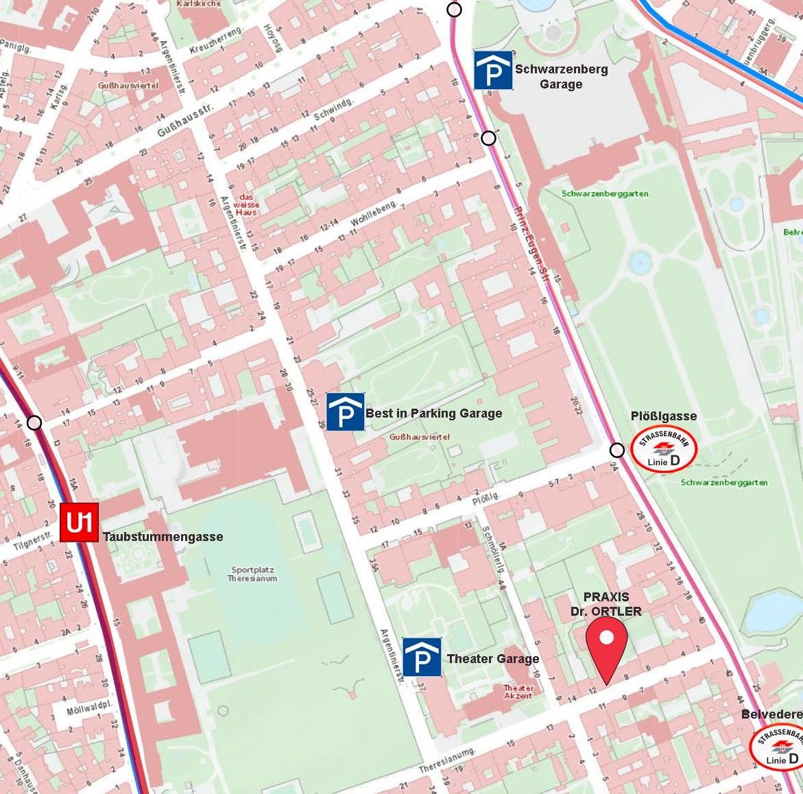

D I R E C T I O N S
​
by Tram: D; Stops Plößlgasse or Schloss Belvedere
by Underground: Line U1, Stop Taubstummengasse
by Car: Parking Garage at Palais Schwarzenberg; BIP Garage Argentinierstr.29,
Street Parking in the Area is limited (must purchase ticket)

